RoamReady — UX Design Hand-off
Itinerary Page: Drive Day & Stay Day cards
Prepared by Cindy (UX) · May 21, 2026

This document covers the redesign of three elements on the trip itinerary page (TripSummaryPage): the “Trip at a Glance” stats bar, the drive day card, and the multi-night stay day card. It contains the written spec plus rendered mockups of the final design for each, so it can be pasted into a coding assistant alongside a request for implementation. Items flagged “Confirm with Benny” should be checked against existing code before building. Items flagged “Behavior / Data” are not purely visual — they change how data is generated or stored.
Design-system note: this follows the locked visual language — pale activity tints come from the status palette (RV-blue #E0F0F4, amber #FAEEDA); gold (#BA7517) is reserved for primary CTAs; status pills use pine for booked. The header tint is the ONLY colored element on each card; bodies stay white.

Change summary
Change | Area | Type
Shrink “Trip at a Glance” to a slim one-line strip | Page top | Visual
Activity-tinted day header (pale blue = drive, pale gold = stay) | Both | Visual
Consolidate DRIVE line (cities + time on one row) | Drive | Visual
Strengthen card borders & internal dividers | Both | Visual
Matching START / ARRIVE bookend labels | Drive | Visual
Bold campground / resort name, moon icon inline | Both | Visual
Weather box → expandable “View weather” link | Both | Visual
Remove “Early departure” tag | Drive | Visual
“Let’s book it!” solid gold → gold outline | Drive | Visual
Rate shows “Est.” before booking, actual rate after | Drive | Behavior
Multi-night stay: one shared activity menu (Model B) | Stay | Behavior + AI
Hover-reveal delete (X) on activities | Stay | Visual

NOTE: Most items are visual. Three are deeper: the estimate→actual rate (reads a field the booking modal already captures), the multi-night shared activity menu (needs an AI-generation change), and the disposable-data migration plan (below).

1 · Trip at a Glance — slim it down
The stats bar at the top of the itinerary (total miles / nights / stops / est. total) currently uses very large numbers in a tall, deeply padded card. It dominates the top of the page and pushes Day 1 well down. The fix keeps all four stats but compresses them into a slim single-line strip.

Final design
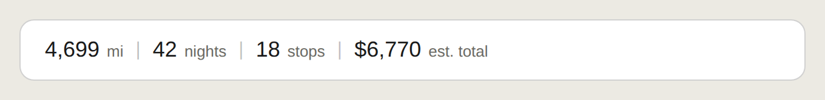
Final “Trip at a Glance” strip. All four stats on one line, numbers reduced to ~18px with their unit beside each, thin dividers between, in a short bordered strip roughly a fifth of the previous height.

What changes
- Compact strip: numbers drop from the large display size (~38px) to ~18px, with the unit label inline beside each value (“4,699 mi”, “42 nights”), separated by thin vertical dividers — all on one row.
- Reduced height: card padding shrinks substantially (from ~28px to ~14px vertical) so the strip is roughly one-fifth its current height.
- Label removed: the “Trip at a Glance” heading label is dropped — at this size the stats are self-explanatory and the label only added height. (Can be kept as a tiny caption if preferred.)
- Honest cost label: keep “est. total” wording on the dollar figure, matching the estimate language used on booking rates.
NOTE: Numbers and units are unchanged — this is purely a sizing/layout change to the existing stats component. On mobile the strip can wrap to two lines if needed.

2 · Drive day card
The drive day is a transit day ending at an overnight campground. The redesign fixes the hierarchy (destination was buried under the drive), calms the gold book button, and bookends the day with matching START/ARRIVE labels.

Final design
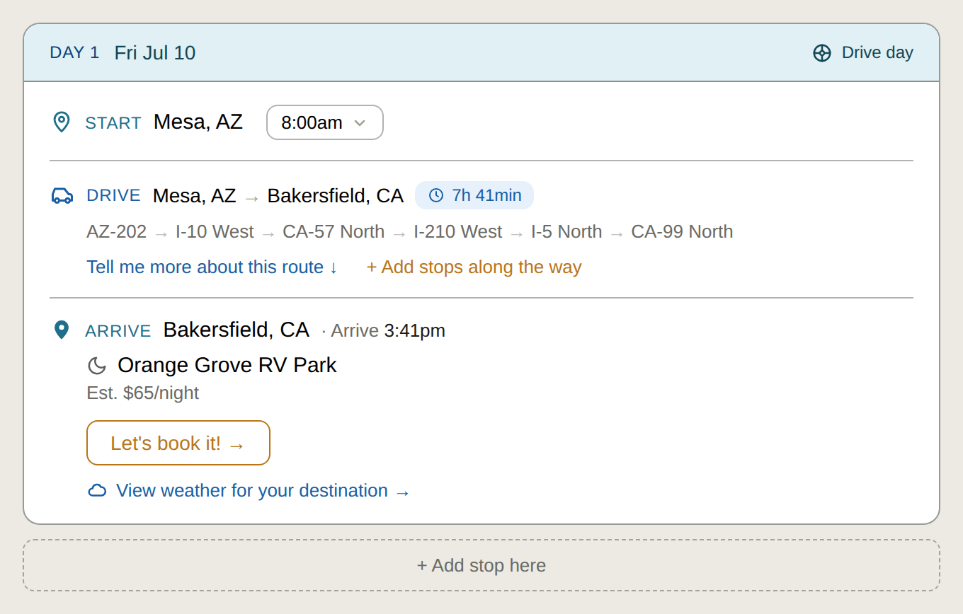
Final drive-day card. Pale-blue activity header, consolidated DRIVE line, strengthened borders, START/ARRIVE bookends, bold campground name with moon, estimated rate, gold-outline book button, weather link.

What changes
- Day header tint: the “Day 1 · Fri Jul 10” header gets a pale RV-blue fill (#E0F0F4) with a small “Drive day” tag at right. Header only — body stays white.
- Consolidated drive line: car icon, “DRIVE”, “Mesa, AZ → Bakersfield, CA”, then the duration chip (7h 41min) all on ONE row.
- Stronger borders: the outer card border and the two internal dividers (start/drive, drive/arrive) move from the faint hairline to a solid ~1px border so the day reads as one clear unit.
- START / ARRIVE bookends: a new “ARRIVE · Bakersfield, CA · Arrive 3:41pm” row mirrors the existing “START” row — same pin icon, same RV-blue label. It sits directly above the campground, pulling the destination up into prominence.
- Bold name + moon: campground name (“Orange Grove RV Park”) is bold with the moon icon inline beside it, marking the overnight. (Moon currently sits as a section-type icon; relocate it next to the name.)
- Weather link: replace the bordered weather box with a single link “View weather for your destination” that expands/collapses. Inline temps are intentionally dropped from the collapsed state.
- Remove “Early departure”: delete the “Early departure” text next to the rate.
- Calmer book button: “Let’s book it!” changes from solid-gold fill to a gold OUTLINE button (gold border + gold text, transparent fill). Still clearly the primary action, but it no longer blows the gold budget when repeated down an 18-stop trip.

Do NOT change
- the highway route description line (AZ-202 → I-10 West …). Leave as is.
- the “Tell me more about this route” link. Leave as is.

Notes & flags
BEHAVIOR / DATA: Rate: estimate → actual. Before booking, show the rate as an estimate (“Est. $65/night”). After booking, drop “Est.” and show the ACTUAL rate the user entered in the booking modal (e.g. “$72/night”), plus nights and site #. The booking modal’s “Actual rate per night (editable, defaults to listed rate)” field already exists per Booking Wave 1A — the card just needs to read from it once the stop is booked, instead of always showing the estimate.
CONFIRM WITH BENNY: Confirm the actual-rate field is wired and that the booked-state display isn’t already being built under Booking Wave 1B (“show saved booking info below each booked campground”). Reconcile this card design with that work so it isn’t duplicated. After booking, the gold-outline button is replaced by a calm pine-green “Booked · conf #” indicator with an “Edit booking” link.
CONFIRM WITH BENNY: “Early departure” — confirm it isn’t encoding a real checkout-time constraint before deleting. If it is load-bearing, it should return as a properly labeled field, not a mystery tag.

3 · Stay day card (multi-night)
A multi-night stay groups into one “Days X–Y” card. Today it repeats the SAME activities under every calendar date (e.g. six identical lists for a six-day stay), which reads as filler and undercuts the AI. The redesign collapses these into a single shared activity menu for the whole stay (“Model B”).

Final design
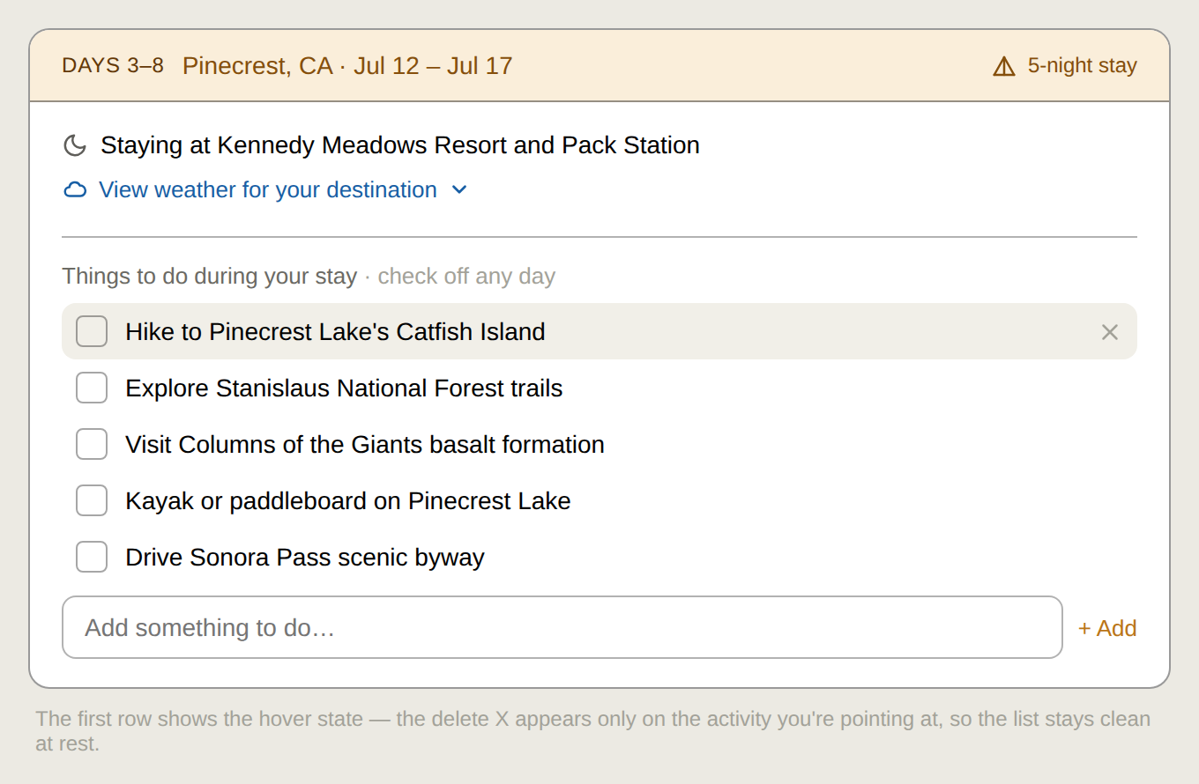
Final stay-day card (Model B). Pale-gold activity header, bold resort name with moon, weather link, and ONE shared “Things to do during your stay” menu replacing the repeated per-day lists. First row shows the hover-reveal delete state.

What changes
- Day header tint: “Days 3–8 · Pinecrest, CA · Jul 12–Jul 17” header gets a pale amber/gold fill (#FAEEDA) with a “5-night stay” tag at right. Header only — body white. (Parallels the drive-day blue header.)
- Bold resort + moon: “Staying at Kennedy Meadows Resort and Pack Station” — resort name bold, moon icon inline.
- Weather link: same expandable “View weather for your destination” link as the drive day.
- Single activity menu (Model B): the repeated per-day activity lists (Sun Jul 12, Mon Jul 13 … each with the same items) are REPLACED by a single “Things to do during your stay” menu. Per-date sub-headers go away — the date range lives in the card header. Activities use checkboxes (check off as done), with an “Add something to do” input at the bottom.
- Hover-reveal delete: each activity gets a delete X that appears only on hover (the row being pointed at), so the list stays clean at rest — no column of X’s. On mobile, surface via an edit affordance or swipe.

Notes & flags
BEHAVIOR / DATA: AI generation change required. Today the planner emits the same activities copied across each date of a stay. Model B needs the itinerary generation to produce ONE de-duplicated activity set per multi-night stay, not a per-day repeat. The UI is built for this shape; the data/generation must match. This is the larger half of this item.
NOTE: Data migration: NOT needed. Existing trips are disposable test data (only Cindy & Benny use the app). Plan: deploy the code first, THEN wipe all trips at the DB level (prisma delete / truncate on trips + stops — cleaner than UI delete, avoids orphaned records), THEN create fresh trips under the new code. Do NOT pre-delete — deleting before coding just leaves an empty app and any trips recreated under old code would have the old shape. Clearing as the final deploy step means the new code never has to render an old-shaped (per-day-repeat) trip.
CONFIRM WITH BENNY: Optional refinement, not in scope now: users with a date-specific commitment (a tour booked on a set day) lose the ability to pin an activity to a day under Model B. If that need arises, add an optional “pin to day” later. Default stays the shared menu.

How to use this doc
Each section above has the spec plus a rendered image of the final target. Paste a section (text + image) into the coding assistant and ask for the implementation. Suggested order: the Trip at a Glance strip first (smallest, isolated), then drive-day visuals, then the estimate→actual rate, then the stay-day Model B change last (it touches AI generation + needs the trip wipe).
Martini AI Media LLC | DBA Roamready.ai | Arizona | May 21, 2026

